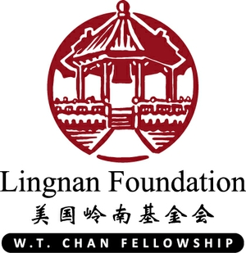
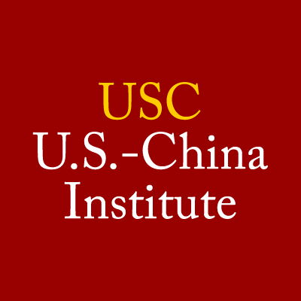Lingnan W.T. Chan Fellowship Program
Graduate Student Facilitator (GSF)
2024-2025
Application deadline: March 1, 2024

The Chan Fellows Graduate Student Facilitator (GSF) supports aspects of the Lingnan W.T. Chan Fellows Program with the U.S.-China Institute. Through this position, the Graduate Student Facilitator will develop knowledge of service-learning pedagogy, Asian American and Asian International cross-cultural engagement, and gain hands-on experience leading transformative educational experiences in a university environment.

Lingnan W.T. Chan Fellows Program Overview

Partnered with the Lingnan Foundation since 2004, the Lingnan W.T. Chan Fellowship is a 5½ month program that invites 6 undergraduate and graduate students from China, Hong Kong, and Central Asia to the United States for a significant intercultural service-learning experience at USC. Fellows intern at nonprofit organizations such as Museum of Tolerance, Little Tokyo Service Center, 826LA that advocate for marginalized communities in the Los Angeles area and live with host families. The Fellowship includes a comprehensive orientation, community-based service internships, and weekly academic seminar culminating with project proposal research, educational excursions, weekly reflections, team buildings, and cultural activities. For more information, please see below or visit our website.

Roles and Responsibilities
Reporting to and in collaboration with the U.S.-China Institute’s Program Manager, the Graduate Student Facilitator (GSF) develops curriculum that support the Chan Fellows reflect on their internship experience, social issues in the Los Angeles, and overall experience of their cultural immersive exchange experience. The GSF co-creates seminar syllabus, prepares lesson plans, facilitates seminars, and supports Program Manager on administrative duties as needed.

Specific duties include, but not limited to:
- Collaborate and co-facilitate seminars with the Program Manager on seminar syllabus and lesson plans Seminars are held once a week all day with lunch provided. Examples of seminar topic include project proposal research project, social justice & community engagement topics, community building, ongoing critical reflections (previous seminar curriculum will be available for adaptation.)
- Coach fellows through challenges they experience with internship site and navigating a culturally immersive experience.
- Assist fellows with developing strong final project proposals and final presentation at the Chan Final Reception through 1:1 coaching, reviewing and revising proposal components, etc.
- Assist with some event planning -- coordinate and facilitate components of the fellows’ orientation in August 2024 (tentative dates: August 1 - 9) and Final Reception Celebration in December 2024
- Prepare and analyze post-program evaluation data and develop a program report
- Participate in monthly graduate student facilitator meetings/trainings
- 1:1 check-in weekly with Program Manager

Minimum Qualifications:
- Currently enrolled in a masters or doctoral program at USC
- Demonstrate interest in experiential-learning, community-based education, and/or international exchange programs
- Strong facilitation, communication and interpersonal skills
- Strong event and program planning experience
- Ability to take initiative and adapt to changing priorities
- Sensitivity to issues faced by international students, and respectful of cultural diversity

Preferred Qualifications
- Experience in nonprofits and community-based organizations.
- Experience working with and knowledge of international student’s needs.
- Knowledge and understanding of history, issues, current events, and experiences in Los Angeles and the world.

Hours: an average of 15 hours/week. Must be available every Friday in the Fall semester from 10am-3pm.
Start & End Date: early July 2024 through December 2024
Compensation: $20 per hour. There is no tuition remission for this position.
Eligibility: PASA & EC students. Incoming and continuing students both encouraged to apply.
Open Positions: 1
Required application Materials: Resume and cover letter.
Contact: Vicki Higgins, USC U.S.-China Institute Program Manager, 213-821-6582, vahiggin@usc.edu

About the U.S.-China Institute
The USC U.S.-China Institute informs public discussion of the evolving and multidimensional U.S.-China relationship through policy-relevant research, graduate and undergraduate training, and professional development programs for teachers, journalists, and officials. It produces compelling public events, widely-viewed documentary films, and the popular magazine US-China Today. USCI was established in 2006 as a university initiative. Its creation was first announced in Beijing during a Board of Trustees trip to China. USCI became part of the USC Annenberg School for Communication and Journalism in 2011.

About the Lingnan Foundation
The Lingnan Foundation, an American philanthropy based in Costa Mesa, California and established in the late 19th century, seeks to contribute to the advancement of higher education in South China and thereby promote understanding between Chinese and Americans. Guided by the example of international collaboration embodied in the legacy of Lingnan University (founded in Guangzhou, China, in 1888), the Lingnan Foundation pursues its mission by supporting scholarly exchange, educational innovation, and service to society.

Lingnan W.T. Chan Fellowship
The Lingnan W. T. Chan Fellowships Program provides challenging educational and leadership opportunities for Chinese students through service learning and intercultural experiences in the United States. At their core, the Chan Fellowships seek to nurture a lifelong commitment to service. Around this core, there are many secondary challenges and benefits for the Fellows. Through service, the Fellows explore challenges ranging from intercultural communication and non-profit professionalism to personal growth and leadership development.

